Programming Exercise 7: Sentence Counter with Regular Expressions
Pedro Clavero De Dios
March 22, 2026
COP 2373

This program uses the look-ahead regular expression from Section 7.4 of the textbook to split a paragraph into individual sentences. The regex pattern has been modified to also handle sentences that begin with numbers. The program displays each individual sentence and the total sentence count.

Function: split_sentences
Splits a paragraph into individual sentences using a regular expression with look-ahead, based on Section 7.4 of the textbook. The pattern is modified to also match sentences beginning with numbers.
Parameters:
paragraph (str): The paragraph to split into sentences.
Variables:
pattern (str): The regex pattern for matching sentences.
sentences (list): The list of sentences found in the paragraph.
Logic:
1. Define a regex pattern based on Section 7.4 that matches sentences.
2. Modify the pattern to also match sentences beginning with numbers.
3. Use re.findall with DOTALL and MULTILINE flags to find all sentences.
4. Strip whitespace from each sentence.
5. Return the list of sentences.
Return:
list: A list of strings, each being an individual sentence.

Function: display_sentences
Displays each individual sentence and the total count.
Parameters:
sentences (list): A list of sentence strings to display.
Variables:
count (int): The total number of sentences found.
Logic:
1. Print a header for the output.
2. Loop through the sentences and print each one numbered.
3. Calculate and display the total sentence count.
Return:
None

Function: get_paragraph
Prompts the user to enter a paragraph.
Parameters:
None
Variables:
paragraph (str): The paragraph entered by the user.
Logic:
1. Prompt the user to enter a paragraph.
2. Return the paragraph string.
Return:
str: The paragraph entered by the user.

Function: main
Main function that runs the sentence counter program.
Parameters:
None
Variables:
paragraph (str): The paragraph entered by the user.
sentences (list): The list of sentences found.
continue_choice (str): The user's choice to continue or exit.
Logic:
1. Display a welcome message.
2. Enter a loop to allow the user to analyze multiple paragraphs.
3. Get a paragraph from the user.
4. Split the paragraph into sentences using the regex pattern.
5. Display the sentences and count.
6. Ask if the user wants to analyze another paragraph.
7. Exit when the user chooses not to continue.
Return:
None

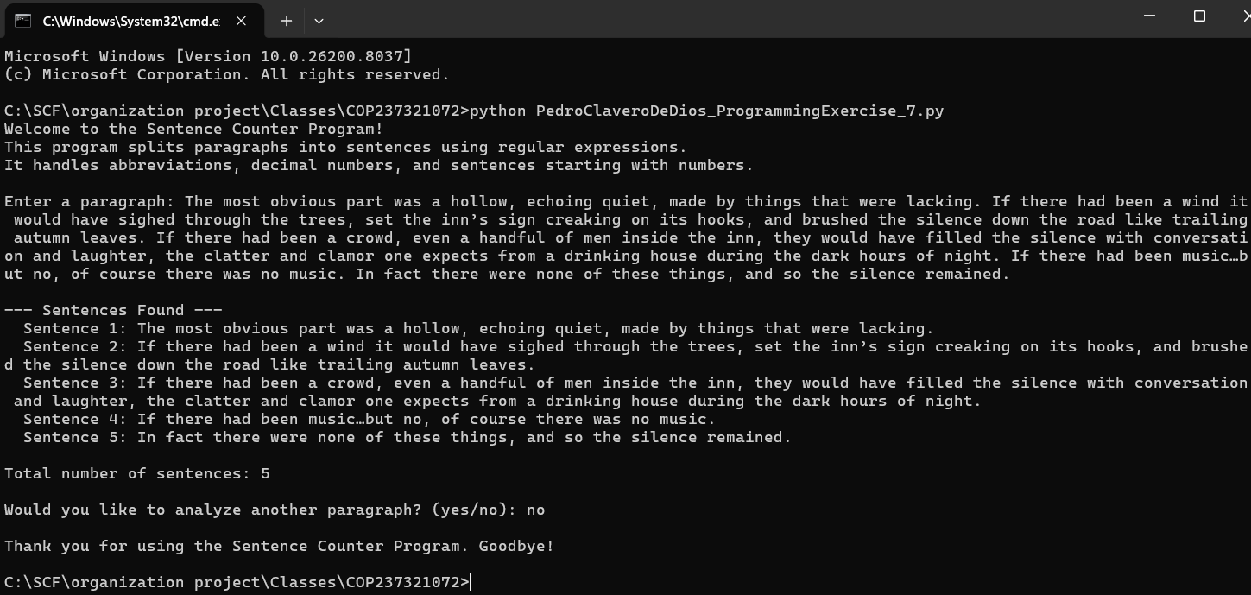
Screenshot:

Repo
GitHub Repo Link: https://github.com/Pclav34/PC_COP2373

